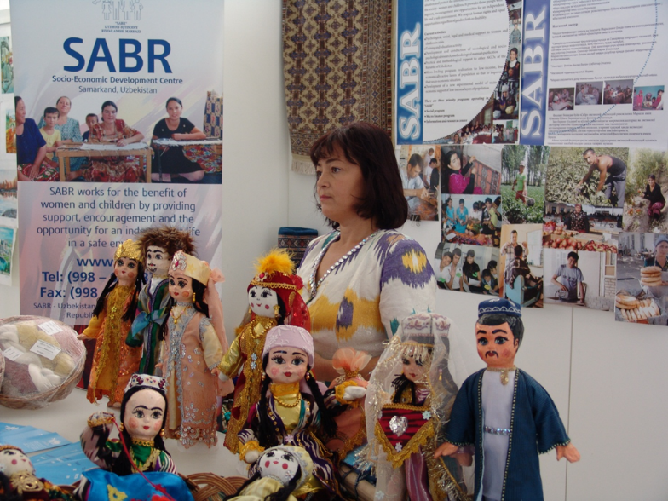
The Republican Center for Social and Economic Development "SABR" was first created as the first Trust Center for women and children in crisis situations (November 1996). Over time, due to the expansion of the scope of activities, the organization was re-registered with the Ministry of Justice of the Republic of Uzbekistan as the Center for Socio-Economic Development "SABR" (March 2005). In August 2016, the organization was again re-registered as the Republican Center for Social and Economic Development "SABR".

The organization’s mission is to help improve the socio-economic situation of vulnerable segments of the population, enhance their citizenship, develop abilities and capabilities through the introduction of social innovations based on democratic values and social partnership.

Priority areas of activity:

• Social programs of various kinds;
• Creation and development of Local Development Centers;
• Microfinance program to support socially vulnerable groups;
• Information resource program.

Social programs include the provision of psychological, legal and medical advisory support to adults and children who find themselves in difficult situations - in person and by telephone hotline. Initially, only psychological and legal support was provided to the target group, but this was not enough. During the consultations on “helplines” and on-site seminars in the countryside, it became clear that more effective measures were needed to develop private entrepreneurship, including involving women in it. So there was a pilot microfinance program, which was subsequently registered as LLC Microcredit Organization SABR. The activities of the ICR in Samarkand and in the Samarkand region use an integrated approach that combines social services in the form of specialist consultations (lawyer, doctor, psychologist) , interactive trainings that help representatives of target groups to raise awareness of a healthy lifestyle, reduce the level of domestic violence against women, increase their social hydrochloric activity and involvement in community affairs and activities to inculcate skills in complex help poor people improve their quality of life.

Main activities:

• provision of psychological, social, legal, medical support to women and children in crisis situations (field meetings with the rural population, face-to-face counseling and telephone hotlines, etc.);
• instilling professional skills for women and youth from socially vulnerable segments of the population;
• Implementation of a microloan program for low-income, economically active sections of the rural population in order to improve their socio-economic situation;
• preparation and publication of teaching aids;
• conducting educational and training activities (trainings, conferences, forums, round tables, media campaigns);
• providing methodological and practical assistance to NGOs.Сотрудники центра проводят семинары, тренинги и информационные встречи с населением. Осуществляется благотворительная помощь детским домам и школам-интернатам.

One of the key topics of the SABR project activity in recent years is the development of the idea of ​​creating Local Development Centers (IDCs), which are known in the foreign countries as Community Learning Centers (CLC). This idea arose eight years ago and is now being developed, tested jointly with state and non-governmental organizations with the support of the Public Fund under the Oliy Majlis, DVV International and other international organizations. In particular, there is already experience in implementing the social order “Innovative partnership mechanisms in solving social problems, ensuring employment of vulnerable segments of the population, especially women and youth, as well as creating new jobs in rural areas of six regions of Uzbekistan” and “Recommendations on the creation of the ICR for based on existing experience "(publication supported by DVV Branch in Uzbekistan).

Target groups of NGO "SABR"

• young women and girls;
• unorganized unemployed youth from poor families;
• farmers;
• students of colleges, lyceums and secondary schools;
• elderly people who want to expand their knowledge and skills in the field of computer, financial literacy, other professions and entrepreneurship in demand.

The aim of NGO "SABR" , which is determined for the near future - further improvement of the experimental model of socio-economic support for the poor and vulnerable segments of the population, in particular, on the example of the pilot Local Development Centers (ICD).

The Republican Center for Social and Economic Development "SABR" is constantly looking for the best ways to provide quality services to its target group. Many projects and programs implemented over the past 22 years have been focused on the needs of target groups - residents of Samarkand and rural areas of the Samarkand region. Over the past eight years, the RSADC “SABR” has been developing activities to create pilot Local Development Centers (Training Centers for the local community) - as one of the forms of involving the population, especially vulnerable segments of the population, in self-government and self-realization, and as one of the models of the educational structure, called contribute to the sustainability of not only target groups, but also NGOs themselves.

Now the NGO "SABR" on the basis of the pilot ICR offers training in nine areas:

• art ceramics;
• art painting on fabric (batik);
• national creativity
(national dolls, soft toys, beadwork, patchwork);
• cutting and sewing;
• confectionery;
• hairdressing;
• computer literacy;
• knitting;
• carpet weaving.

The partnership activities of the NGO SABR and DVV International have been ongoing for 6 years (since 2013). During this period, several projects and complexes of events were implemented with a total value of about 150 thousand euros. In the Urgut, Akdarya districts and the city of Samarkand, projects were aimed at supporting the organizational and institutional development of the RC “SABR”; improving the well-being and quality of life of mainly young women and girls from poor families.

Table 1. Projects implemented with the support of DVV International in 2013 – 2018

name of the project | Implementation period | Result
Supporting the development of sustainable livelihoods of the local community and improving living standards in rural areas | July -  November 2013 | 57 women and girls received professional skills
Supporting the development of sustainable livelihoods of the local community and improving living standards in rural areas through the activities of the ICR | July 2014 -  november 2014 | 40 girls and women  got professional skills
Supporting the organizational development of the NGO “SABR” and instilling professional skills for socially vulnerable groups with a focus on girls and women | August 2015 -  january 2018 | 618 people have acquired professional skills.
Social innovation to increase the competitiveness of vulnerable groups | October 2018 -  january 2019 | 24 pax from 5 regions attended master classes in 6 professional fields. 18 employees of the center underwent training on the establishment of the ICR.

The main idea of the events in a joint partnership with DVV International was to improve the quality of vocational training and the provision of educational services to socially vulnerable groups. The idea of a set of measures fully coincided with the National Programs and measures carried out by the Government of the Republic of Uzbekistan and aimed at supporting the poor.

During the implementation of projects:

• supported the organizational and institutional development of the NGO “SABR”;
• trainings were held with the project executors (mentors of the ICR, employees of the Center for Social and Political Development "Saber") on such topics as "Organization and methods of adult education";
• training modules in professional areas were developed with the involvement of specialists, including those from Tashkent;
• informational meetings of an educational nature took place - lectures, seminars, trainings and consultations with the interested circle of the NGO "SABR";
• assistance was provided in the advanced training of managerial staff and mentors;
• ICR equipped with the necessary equipment;
• Study tours to various countries were organized for SABR employees in order to familiarize themselves with foreign experience.

Further cooperation between DVV International and the partner organization SABR in the coming years will be based on the further development of the idea of creating and strengthening the CLC network (ICR).

