PROJECT

"CONTRIBUTION TO THE DEVELOPMENT OF CULTURE AND LEISURE CENTERS OF THE POPULATION OF REPUBLIC OF UZBEKISTAN »

REPORT ON THE RESULTS OF THE FIRST PHASE IMPLEMENTATION
(Covers the period 2015-2018.)

Compiled by:

Nodir Rakhimov,
Project manager of
DVV Branch in Uzbekistan

CONTENT

INTRODUCTION. PROJECT ACTUALITY
SECTION 1. RESULTS OF EVALUATION OF POTENTIAL CULTURE AND LEISURE CENTERS OF PILOT REGIONS POPULATION
SECTION 2. DESCRIPTION OF EVENTS ON STRENGTHENING THE POTENTIAL OF PILOT CENTERS OF CULTURE AND LEISURE POPULATION
SECTION 3. GENERAL CONCLUSIONS ON THE FIRST PHASE OF THE PROJECT AND RECOMMENDATIONS FOR FUTURE
Applications:
1. Photos of the project in Namangan region
2. Photos of the project in the Karshi district of Kashkadarya region

PROJECT ACTUALITY
Considering the importance of adult education and non-formal education as a tool for encouraging citizen participation in cultural, social, economic and sustainable development, and also to increase the level of welfare, the Branch Office of the German Adult Education Association (DVV) in Uzbekistan carries out project activities aimed to strengthen the capacity of formal and non-formal education and training structures for youth and adults.
The centers of culture and leisure of the population established on the basis of the former houses of culture and club institutions, being in the form of ownership by a state organization mainly operate in the informal sector, offering a variety of cultural and educational services (sections, art and discussion clubs, meetings with cultural figures and others). According to the plans of the Government, by 2018 the number of such centers of culture and leisure of the population should be 894..
According to the decree, the main objective of implementing reforms in this area is to create the necessary conditions to satisfy the growing cultural and educational needs of the population, especially the young generation, as well as to help them organize productive and meaningful leisure time.

The centers currently mainly working in the field of culture and art - they offer to the local population (mainly schoolchildren, students) various sections of music, singing and dancing (including participation in creative ensembles), as well as massive cultural and entertainment events for the general population. (concerts, theatrical performances, etc.).

On the Centers being created, in addition to those functions that had previously been performed by houses of culture and club institutions, were assigned new responsibilities for “disseminating modern cultural and educational services demanded by all segments of the population, creating Internet studios, courses on information technology and foreign languages” as well as “provision in the framework of Center capabilities of various paid services of a socio-cultural character to the population, taking into account their needs” (paragraphs from the Regulations about Culture and Leisure Centers of population).

A preliminary acquaintance with the activities of the Centers, conducted in early 2016, showed that the implementation of these very, relatively new functions remains a difficult task for the staff of the Centers. The technical furnishing and equipment of the Center is insufficient - there is a lack of modern audio, video and lighting equipment, computer and equipment for conducting courses of various directivity. In addition, the staff of the Centers do not have sufficient knowledge and skills to organize and conduct training activities for various categories of the population.

In order to promote the development of potential of the Culture and Leisure Centers of the Population, the DVV Branch in Uzbekistan and the Ministry of Culture of the Republic of Uzbekistan signed a Memorandum about Cooperation at the end of 2015.

Joint activities are aimed at enhancing the potential of the Cultural and Leisure Centers of the population through acquaintance with modern approaches on management, with activities aimed at increasing the access of the city population, district and region to various cultural and educational services. Important tasks here are the issues of increasing the number and improving the quality of events, courses, clubs, as well as increasing the number of visitors from different target groups (women, disabled, elderly, unemployed youth, etc.).

In 2016, the Center for Culture and Leisure of the Namangan Region was identified as the first location for testing project ideas (by agreement with the Ministry of Culture and Sports). At the beginning of 2017, the parties reached an agreement about inclusion to implementation of the project of the Culture and Leisure Centers of the population of Karshi district of Kashkadarya region as the second pilot location.

The overall objective of the project: To contribute to the improvement of the effectiveness of the informal education and adult education system in the regions of Uzbekistan through innovative approaches.

Project Objective: Expanding the range of cultural and educational services of the Culture and Leisure Center of the Namangan Region through the strengthening of institutional capacity and the organization of courses demanded by various categories of the population.

Target groups of the project: women and youth from socially vulnerable groups of the population in selected regions; population of selected regions, regardless of age, gender and social status; employees of the of the culture and leisure centers of the population operating in selected areas.

It is expected that the advanced training courses provided for the staff, the administration of the Center itself and the nearby Centers, seminars, round tables will allow to introduce the innovative approaches of managing the activities of cultural and leisure institutions of the region.

Strengthening the material base of the Center and primary financial support for professional courses (modeling, cutting and tailoring; decorative arts; computer literacy basics; photo and video editing, etc.) and educational orientation (personal development, etc.) for the population, will increase access different target groups for cultural and educational services.

The accumulated positive experience of the project will be summarized and systematized, further multiplied into other Centers of the Republic.

In this report presented the results of the first phase of the project, as well as recommendations were made for the future.
RESULTS OF POTENTIAL EVALUATION
OF CULTURE AND LEISURE CENTERS IN PILOT REGIONS

The capacity assessment of the pilot centers of culture and leisure of the population was carried out by an employee of the DVV Branch in two stages.

At the first stage, a preliminary assessment of the Centers potential was carried out through interviewing their employees and visiting the premises. The assessment was carried out on the basis of common criteria (the presence of motivation, the readiness of the management and staff of the Center in participation in the project, the availability of free places, the collection of general information about the material and technical potential of the Center).

Second stage: an in-depth assessment of the Centers' potential was carried out by conducting interviews with management and staff based on specific indicators (the mission’s vision of the organization, an idea of the current and potential target groups of the center, the name of sections / programs / courses and the number of people trained in 2014-2015, the resource base, human resources, funding sources, etc.) through using a special questionnaire. The following are the results of the assessment.

Employees of the СLCP (Culture and Leisure Center of the population) of Namangan region formulated the mission of the organization as follows: “Raising the level of culture and inculcating a love for art among the population”, and the staff of the CLCP of the Karshi region - “Providing services in the sphere of culture”. It is easy to see that the given formulations are weakly noticeable second, no less important function of the center, as the provision of educational services to the local population in the form of organizing various seminars, lectures, courses and sections.

The collection of information about target groups was carried out with the help of two questions: To which groups of people does your Adult Education Center provide services? What groups of people could your adult education center provide services in the future?

The following table shows the responses of the administration of the CLCP of Namangan region:

 | TARGET GROUPS COVERED BY THE CENTER | POTENTIAL TARGET GROUPS OF THE CENTER
CLCP of Namangan region

 | Students of nearby colleges | Students of secondary schools
 | Students of secondary schools | College and university students
 | Residents of nearby mahallas (participation in performances, holidays, concerts of the Center) | Employees of state and commercial organizations
 | Employees of local enterprises (organization of corporate celebrations).
CLCP of Karshi region

 | Children | Women (organization of lectures and seminars "Healthy lifestyle", "Proper nutrition, as a way to prevent weight gain")
 | Pupils of general secondary schools | Lectures for young families;
 | Adults (ensemble members) | Adult population (organization of courses on computer literacy, sewing / folk crafts and hairdressing);
 | Employees of local enterprises (organization of corporate celebrations) | Youth (foreign language courses);
 |  | Fitness club for the elderly people;
 |  | District population (checkers, chess)

As can be seen in the table above, employees of the Culture and Leisure Center of the population have a clearer idea of the future possible target groups, but the lack of material and technical base did not allow to put these ideas into a life.
According to the approved practice, the Centers have the right to provide paid services to the population. At the time of the assessment, the following types of sections and ensembles operated in the center:

NAME OF SECTION / COURSE | NUMBER OF EDUCATED ONES FOR 2014–15 year | SOURCES OF FINANCING
CLCP of Namangan region

"Guitar" | 12 | population deposits
Song | 12 | population deposits
Happy girls | 12 | population deposits
Window to the world | 10 | population deposits
Circus show | 10 | population deposits
Total: | 56
CLCP of Karshi region

Doira | 76 | population deposits
Dancing | 20 | population deposits
Sewing | 45 | population deposits
Karate | 18 | population deposits
Rubob-song | 18 | population deposits
Folklore | 12 | population deposits
Total: | 190

The table above shows that the number of persons covered by the paid services of the center is rather low. It is also important to note here that such low rates of coverage are available even at fixed low payment for visiting sections (5,000 summs per month). Such a low price is supported due to the fact that the payment of the leaders work of the sections is provided from the state budget. The main source of funding for the Centers' activity is the state budget (about 90%), as well as revenues received through the organization of celebrations commissioned by local organizations / enterprises and section activities.

Such low rates of population coverage do not correspond to the potential of centers that have a large number of premises for organizing educational and training activities. Despite the existing potential, their technical equipment remains rather low, especially when viewed from the point of view of organizing various courses for the public. During the assessment of the potential, it turned out that the funds allocated from the state budget for technical equipment are mainly directed to the purchase of musical instruments and other equipment necessary for the organization of the “cultural component” of the activity.

The personnel potential of the Centers was determined by the following criteria: the number of full-time and freelance employees; methodological support of sections (the level of education of teachers; the presence /absence of special training on the features of adult education; the procedure of developing training programs for sections and their quality).

The evaluation results showed that 29 people works on a permanent basis at the CLCP of the Namangan region

Director, accountant, specialist on organizing the activity of the section, specialist in spirituality and enlightenment of the growing up generation and youth, head of the video studio, engineer –technician, artistic director of the song and dance ensemble “Namangan Gullari”, artistic director of the vocal and instrumental ensemble “Samo”, director of the national team of ropewalkers with name "Namangan Sehrgarlari", the musical leader of the ropewalkers (two people), head of the national puppet theater “Oltin Kalitcha”, producer of the national puppet theater “Oltin Kalitcha”, musical director of the vocal-instrumental ensemble “Samo”, choreographer of the ensemble of song and dance “Namangan gullari”, head of the “Gitara” group, head of the section "Song", artistic director of the center (2 people each 0.5 став.), costumier and technical staff (8 people.).

Unlike the СLCP of the Namangan region, the CLCP of the Karshi region is not an independent legal entity, but integrated into the cultural department of the region, which includes:

Head of the culture department, chief accountant, assistant accountant, specialist in cultural and educational work, artistic director of the Culture and Leisure Center of the population, Clerk of the Culture and Leisure Cente of the population, section Work (2) and studio Specialist of the Culture and Leisure Center, Head of the culture and leisure Center of the population, specialist in work with young people of the CLCP, dance teacher of the CLCP, producer of the CLCP, sound producer of CLCP.

There are responsible persons for educational activities in the staff of the CLCP Department of the Karshi District. However, their potential is not sufficiently used to expand the range of services of the center.

In the course of the capacity assessment, meetings were held with the administration and employees of the partner CLCPs, on which issues of cooperation discussed with a special focus on the organization of events (courses, seminars, lectures) that could be interesting for the population both in terms of generating additional income also gaining knowledge on selected current topics.

Development services of the culture and leisure centers of the population to local residents, according to workers, it is one of the most pressing issues. According to their opinion, most of the leaders of the Centers have a poor idea of how this process can be organized, so seminars and trainings aimed at improving the skills of workers of this and other CLCPs would help to improve the quality and expand the range of services provided to the population. Practically all the employees of the pilot Centers could not name the training events for the last 3-4 years.

A potential assessment revealed the following problem areas:

- provision with qualified personnel;
- the need for effective methodological support of activities;
- Inadequate material and technical base, which does not allow to conduct courses taking into account the educational needs of the population;
- ignorance by the Center heads of the new ways of managing the activities of cultural and leisure institutions;
- Lack of multi-channel financing activities of the Centers;
- insufficient range of services and offers provided to the population;
- Insufficient involvement of various social groups to the activities of the Centers (disabled, elderly, unemployed youth, etc.).

Conclusions and recommendations on the results of the capacity assessment:

- In the activities of the pilot CLCP, educational work for the population is poorly traced, which was determined by Government Decree No. 178 of June 25, 2013. In the ideas of the staff about the mission of the center, cultural activities prevail;

- The level of attendance at CLCP is low, the potential of the available premises is poorly used, and the coverage of section activities is low;

- Among the staff units there are no responsible persons for the development of educational activities of the center;
- Expansion of the services range of the Center is hampered by the factor of insufficient material and technical base, which does not allow conducting courses with regard to the educational needs of the population. The employees themselves do not have sufficient experience and knowledge in the field of organizing and holding such events;

- For employees of CLCP, knowledge and skills are required in the field of management, marketing of educational services, as well as organization and conduct of educational activities for adults.

- To efficiently organize the work of the pilot CLCP, it is necessary to develop an event plan that takes into account changes in the management methods of the center with the use of modern management technologies and marketing of educational services;

- To Consider the possibility of creating and technical equipment of the premises in which to create a training room, an ICT studio, a workshop for tailoring and arts and crafts, as well as a workshop for the production of national musical instruments (CLCP of Karshi district);
- On a competitive basis to attract local specialists who are able to organize training courses in accordance with the chosen areas of activity. Also, develop a strategy of activities aimed at the gradual improvement of their skills in the field of modern adult education methods, as well as their specialization.
DESCRIPTION OF THE EVENT ON STRENGTHENING THE POTENTIAL OF PILOT CLCPs

The activities of the project consisted from the three key components: strengthening the material and technical base, staff qualification, development of educational programs for the public..

Strengthening the material and technical base.
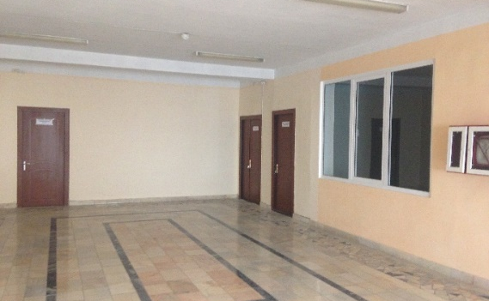
At the initial stage of the project, in 2016, by CLCP of the Namangan region was held repairs of three premises allocated for the creation of a training base, and the DVV Branch provided financial support in acquiring modern equipment (computers, sewing machines, etc.) and educational equipment (cabinets, tables, chairs and boards, etc.), necessary for the organization of effective training.

As a result of this work, in 2016, the following classrooms were created on the basis of the Central Clinical Hospital of the Namangan region:
- Workshop "Modeling, cutting and tailoring, and decorative arts"
- Studio "Information and communication technologies"
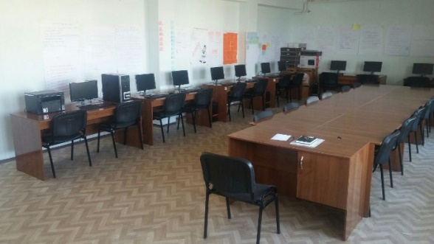
- Training class.
In 2017, in the framework of the project funds were allocated for the purchase of equipment for the courses “Photo and Video”, as well as for the installation of 5 air conditioners and blinds for the training rooms of the center. The total amount of funds allocated to strengthen the material and technical base amounted to 160,963,600 (this is about 35,000 euros).

Due to the fact that in 2016, the CLCP of the Karshi region was capital overhauled, there was no need to repair the premises. The DVV branch provided financial support for the purchase of modern equipment (computers, sewing machines, etc.) and educational equipment (cabinets, tables, chairs and boards, etc.) necessary for the organization of effective training.
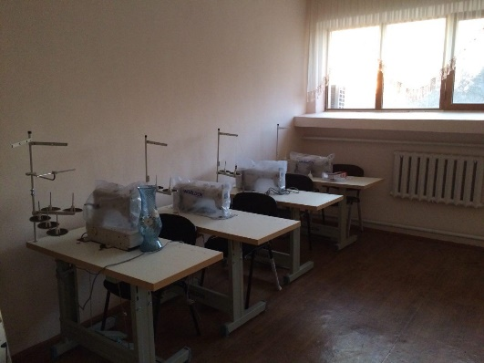
As a result of this work, in 2017, the following classrooms were created on the basis of the Center:

  - Workshop "Modeling, cutting and tailoring, and decorative arts";
  - Workshop "production of national musical instruments";
  - Studio of "Information and communication technologies";
  - Training class
.
Funds were also allocated for the installation of 7 air conditioners for classrooms and for two administrative rooms of the center. The total amount of funds allocated to strengthen the material and technical base of the Center was 201,254,360 summs (this is about 25,000 euros).

Staff development.

This activity has become as a one of the most important activities of the project, not only because of the high needs identified among the staff, due to the lack of an advanced training system for employees of the CLCP, but also the fact that providing cultural and educational services requires specific knowledge and skills. management, marketing of educational services, as well as the organization and conduction of educational activities (including adults). All this required the development of a strategy for measures aimed at the gradual improvement of the qualifications of CLCP employees.
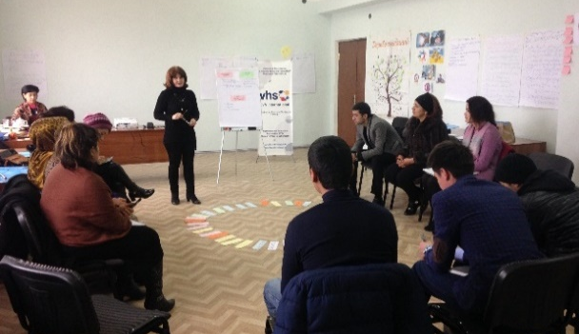
A series of trainings “Features of the organization and conduction of adult education” was conducted for people involved in the project as a teacher (in selected areas of study). During the training, participants were familiarized with current trends and approaches in adult learning and education, as well as with the principles of developing modular curricula. Two graduates of “Curriculum ClobALE” were invited as trainers.

After the trainings “Features of the organization and conduction of adult education” and the expiration of a certain time, coaching was organized, which aimed to improve the quality of training through the organization of mentoring in the workplace. Coaching was conducted in two directions: "Interactive Adult Education Methods" and in the areas of "Basics of Computer Literacy" and "Sewing". Coaching took place in the following order - at the beginning, external experts conducted direct observation of the teachers' work with the project participants through visiting the project courses, then, upon completion of the classes, a series of individual feedback sessions were organized for the mentors, and the coaching process was completed by the involved experts of the master-classes for mentors of the project on the third day of their work.

The organization of trainings and coaching in certain periods of course implementation created the prerequisites for improving the quality of courses and gave opportunity to course instructors to improve their pedagogical level in conducting courses for various categories of the population (including adults).

If the aforementioned activities were intended to improve the qualifications of the course instructors, then a separate group of trainings was conducted for the management personnel of the CLCP, operating in Namangan and Kashkadarya regions. The training program included a change in the management methods of the center with the involvement of modern management technologies and marketing of educational services. For example, three trainings were held on the topic “Features of the management of cultural and leisure institutions”. The training was conducted by experts of the local organization “Oxus culture”.

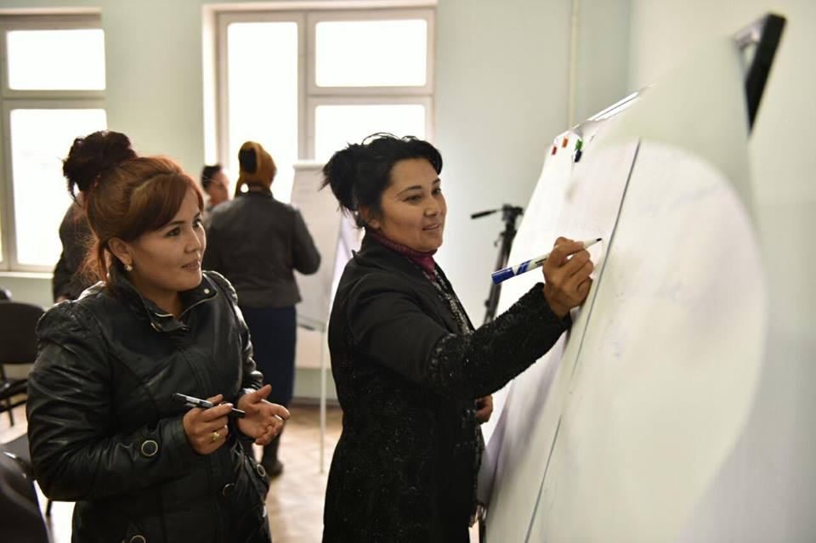
In the framework of these trainings, participants got a general idea about the features of the project approach as one of the effective approaches used in modern management, learned about the “project life cycles”, “Logical Framework Approach” as one of the effective tools used by various organizations (incl. international donor organizations) to develop the project, as well as the main components of the project concept, have gained some experience in developing the project’s logical matrix.

Another training held for employees of the Culture and Leisure Centers of the Namangan region was the seminar “How to make money on education”, during which participants were familiarized with modern approaches of marketing of educational services (market analysis, educational program planning, counting of net cost, also for channels of promotion of educational courses).

Also, two trainings were held on the topic of “Modern methods of organizing and conducting cultural and educational events”, the purpose of which was to familiarize participants with innovative methods of organizing cultural and educational events based on learning from the experience of leading foreign organizations and develop skills for their use on the activities of CLCP.

In total, over 120 employees of the Culture and Leisure Centers of the Namangan and Kashkadarya regions took part in the above-mentioned trainings. The absolute majority of the participants of these events in the feedback questionnaires highly appreciated the substantive, methodological and organizational aspects of the trainings held, stressed the importance of the topics considered for their practical activities and expressed a desire to participate on similar trainings in the future.

Development of educational programs for the population.

Assistance to the development of a spectrum of educational services focused on socially vulnerable groups of the population (women and youth) by forming a portfolio of high-quality and in-demand proposals of the Center is one of the important tasks of the project. These are events such as:
- Short-term courses on the formation of professional skills (from 1 to 1.5 months). The duration and focus of these courses were determined depending on the needs and starting level of the project participants.

- Trainings that are aimed at the development of personal qualities (leadership, successful communication, self-presentation, etc.). These trainings are intended both for listeners of short-term courses, and for other interested parties.

- Lectures and seminars of cultural and educational format on general education topics (gender equality, environmental issues, healthy lifestyle, preventive medicine, etc.).

During the implementation period of the first phase of the project, the first and second types of educational services were tested at the Center of Culture and Leisure of the Population of Namangan Region. In 2016, 180 people (women and men, people with disabilities, the elderly, unemployed youth, etc.) attended courses on the development of professional skills (“Cutting and sewing”, “Basics of computer literacy”). In 2017, new courses were added to these areas of training: “Assistant office manager” and “Photo-video filming”.

In January 2018, the project “Personal Growth” was held for the project listeners, which was attended by project listeners from 18 to 25 years old.

In total the professional skills development courses (“Cutting and sewing”, “Assistant office-manager”, “Photo-video shooting”), and “Basics of computer literacy” from 2016 to March 2018 were visited by about 400 people free of charge.
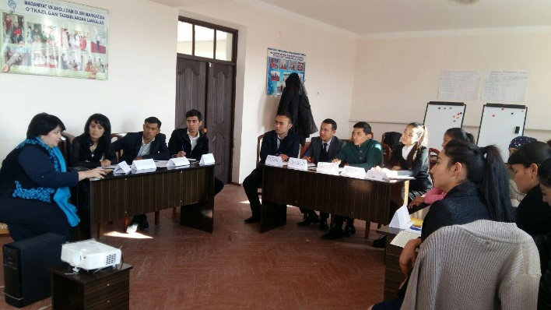
One of the distinguishing features of the project in the Karshi district is that in 2017 it was possible to test new activities with young people in the framework of the “SCHOOLS OF YOUNG LEADERS”, the goal of which is to promote the development and strengthening of key skills and competencies of young people so that they can find themelves in the labor market and become self-confident citizens actively participating in solving socially oriented tasks of society.

The selection of participants was carried out through an open competition, in which all interested persons in the age 18–25 years living in the Karshi district of Kashkadarya region could participate,
having the desire and opportunity to participate in the seminars:

As a result, 17 people passed the competitive selection, for which trainings were held:

- “Leadership and I, as a leader. Self-knowledge” (November 16–18, 2017). Objective: Development of leadership thinking, leadership qualities and the ability to organize teamwork.

- “Successful communication, oratory and presentation skills” (December 14-16, 2017). Objective: To develop skills for successful (productive) communication and public speaking.

In preparing the trainings, the modules of the regional educational program “Strengthening leadership skills and key competencies” prepared by experts of DVV International in 2016 were taken as the basis. The seminars were conducted by experts with extensive experience in conducting educational programs for young people.

The results of the seminars in practice showed the relevance of the idea of creating a “School of Young Leaders” for many reasons. The first is that the youth of the Karshi region until this time did not have the opportunity to participate in such trainings aimed at developing the so-called “Soft skills”. Secondly, in all participants there were positive changes in each participant in terms of increasing self-confidence and self-reliance. Participation in trainings helped them not only in formulating goals, but also in developing plans to achieve them. There were also signs of increased team solidarity among a selected group of young people, an increase in the sense of their responsibility in solving the social problems of their area. So, for example, the participants of the “School of Young Leaders” became active agitators among the population of skills development courses, assisted in organizing and conducting other activities of the LCLP of the Karshi region.

In addition, during the first phase of the project at the Center for Culture and Leisure of the Population of the Karshi District, skills development courses - “Cutting and Sewing”, “Making National Musical Instruments” - (women and men, the elderly, unemployed youth, etc.), as well as the basics of computer literacy, about 120 people visited for free.

Approximately 200 people took part in the seminars “Healthy Lifestyle” and lectures / meetings on current culture, art and effective leisure time activities.

CONCLUSIONS AND RECOMMENDATIONS ON THE FIRST PHASE OF THE PROJECT

The results of the first phase showed the viability of the main project idea - the use of the base of the Culture and Leisure Centers for the development of the informal education sector. With certain investments and proper organization of work, the CLCP base can serve for various categories of the population as a space of non-formal education and training, which is distinguished by its efficiency / effectiveness, which is provided by the following factors:

- Absence of necessity for construction and repair of buildings / premises, as a large number of centers of culture and leisure of the population, due to the implementation of the state program, have passed or at the stage of capital reconstruction and equipment;

- Availability of a wide network of centers located in settlements, including remote ones, which gives them great advantages in terms of access to target groups;

- The centers of culture and leisure of the population are public institutions that have stable government funding, and are entitled to carry out income-generating activities through various cultural and educational services.

Despite the above advantages of the Culture and Leisure Centers of the population, they have a number of problems and unused opportunities. The following table shows the results of a SWOT analysis of the potential of the CLCP network:

SWOT-analysis table of the CLCP network
on the example of pilot regions

Strong sides | Weak sides
Well renovated buildings and premises. | Weak material and technical base for the organization of training
The presence of full-time employees financed from the state budget | Lack of advanced training system for employees
The presence of a wide-spread CLCP network | Insufficiently stable connections between CLCP and social partners
Availability of rights to conduct commercial services for the population | Weak experience in organizing and maintaining commercial services for the population
 | Low population coverage of circle activities
 | Lack of the 2nd and 3rd categories of CLCP's own account
Opportunities | Threats
Relevance for the country of development of non-formal adult education | The appereance of strong competition from non-state educational institutions
A large number of unemployed people in the region | Mistrust of the population to the quality of CLCP educational services
Public interest in obtaining new knowledge / skills / competencies | The rapidly changing market conditions for educational services
The rapidly changing market conditions of educational services | Reduced solvency of the population
Support from the DVV Branch and other donors

One of the weaknesses of the CLCP is the lack of a system of retraining and advanced training of employees of the CLCP. Further analysis of this problem showed that this is an objective reason. For example, in the city of Tashkent there is a Center for retraining and advanced training of teachers at the State University of Arts and Culture of Uzbekistan. However, a study of its activities showed that the employees of the Center for Social Development and Science are not among the participants in the advanced training courses of this center. This Center for Advanced Studies mainly covers the teaching staff of higher educational institutions and institutions of secondary specialized, vocational education. Classes are held in such areas as:

- Theory of art history and cultural studies;
- Director and acting;
- Fine and applied arts;
- Musical art;
- Choreography and stage skills

The presidential decree from May 31, 2017 states that “the effective implementation of the unified state policy in the field of culture, the full implementation of the tasks are hampered by the fact that the training does not take into account the real needs of the sphere, there is no clear system of their retraining and advanced training”. To solve this problem, the Ministry of Higher and Secondary Special Education and the Ministry of Finance of the Republic of Uzbekistan are charged with taking measures to organize a special department in the State Conservatory of Uzbekistan for the training, retraining and advanced training of music teachers for institutions of higher and secondary special education from the 2018/2019 academic year, also for institutions of extracurricular education in the field of culture and art.

Actual processes of reforming the cultural sphere shows that the government has begun to actively decide issues of training, retraining and advanced training of cultural workers. However, the issues of retraining and advanced training of employees of the CLCP are still without attention. This issue needs to be resolved in the near future, so that the employees of the CLCP will have the opportunity to upgrade their skills and be able to use modern management approaches and provide high-quality cultural and educational services to the population. As the project experience has shown, for this they need to pass through a series of trainings / refresher courses in areas such as: management features of a cultural and leisure institution, marketing of educational services, etc. All these activities should be aimed at changing the thinking of the management team in the first place, so that they begin to perceive their institution as a platform that would serve as a place for the local population to acquire new knowledge, skills, effective leisure time and the development of creative ideas that benefit development of people and area. For this, it is necessary that the management of the CLCP begin to position itself as the organizers of various cultural and educational programs and be able to regularly develop and introduce new ideas and to attract external specialists (on a fee-based basis) as lecturers, mentors and teachers.

Another weak side of the CLCP is the weak material and technical base for organizing public education. Funds allocated from the state budget are directed to the capital reconstruction of buildings and premises, and funds allocated for technical equipment are mainly directed to the purchase of various musical instruments and other equipment needed to organize the “cultural component” of the CLCP activity. It is advisable to direct further steps for the technical equipment of the Central Designing Clinical Hospital for the creation and technical equipment of educational premises.

From this it follows that the development of project experience in other CLCP is possible, but subject to the resolution of some systemic issues:

- creation of an effective training system, retraining and advanced training of employees of the CLCP;

- allocating funds on a regular basis to improve the material and technical base for conducting effective training;

- introducing mechanisms that encouraging employees of the CLCP for the introduction of new paid services for the population (phased allocation of the 2nd and 3rd categories of the CLCP of the authority to open a current account and additional staffing units; introduction into practice of the Ministry of Culture of the annual tenders to provide the CLCP on a competitive basis additional financial resources to support the introduction of new ideas / services in their activities, etc.).

The project activities in the next phase should be directed not only to develop and test innovative programs / services for training various segments of the population (including training programs to improve the skills of CLCP employees), but also to achieve the aforementioned systemic changes in the practice of CLCP.

ANNEX 1

PROJECT PHOTOS:
REPAIRING AND EQUIPMENT OF PREMISES LCLP of the NAMANGAN REGION

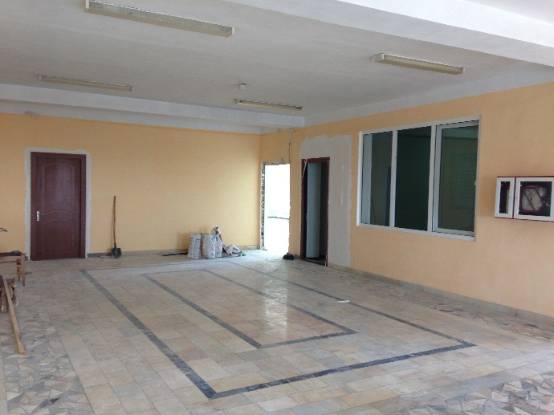 | 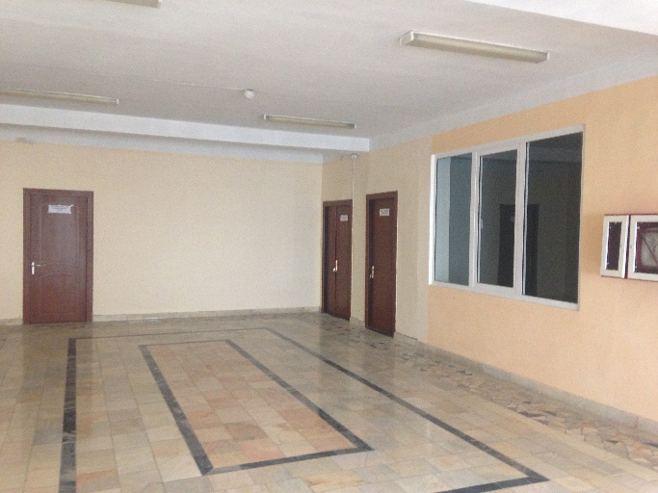
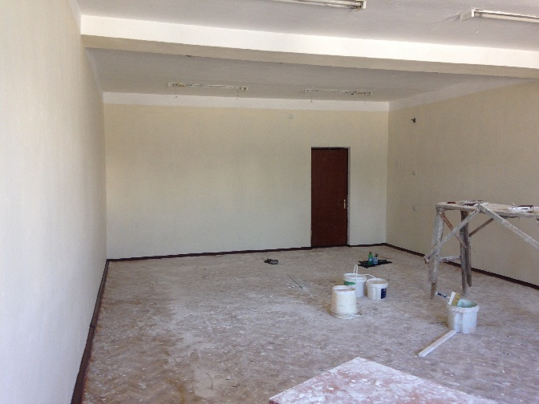 | 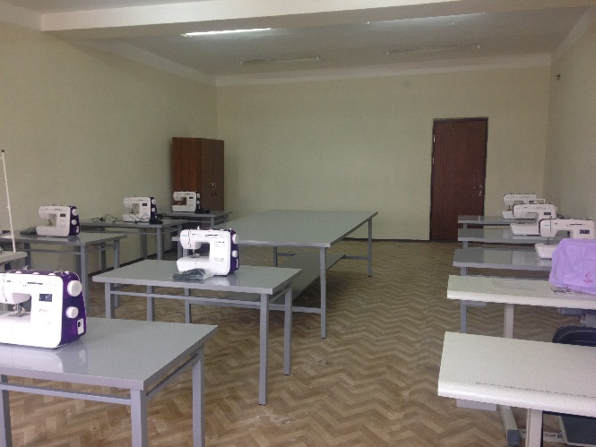
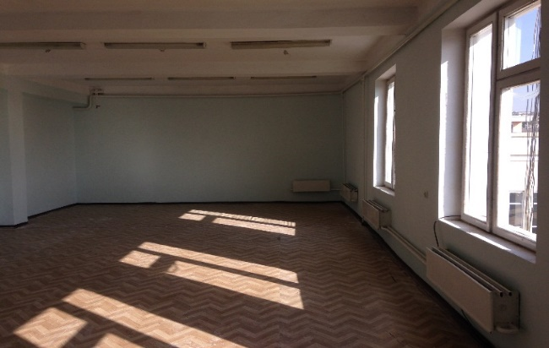 | 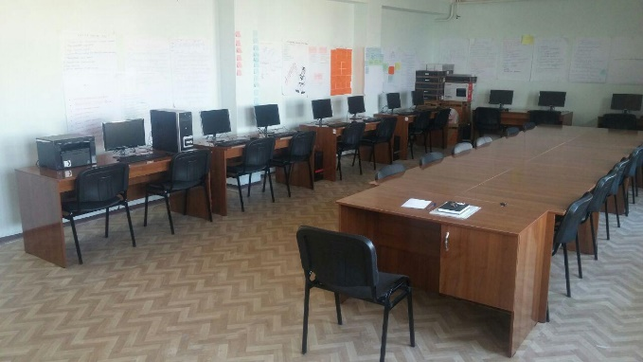

PROJECT PHOTOS:
TRAININGS / SEMINARS FOR EMPLOYEES OF LCLP IN NAMANGAN REGION

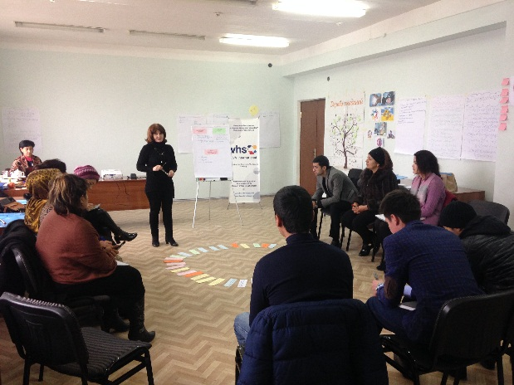 | 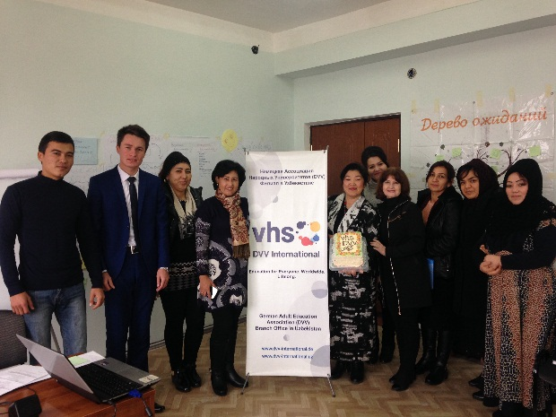
 | 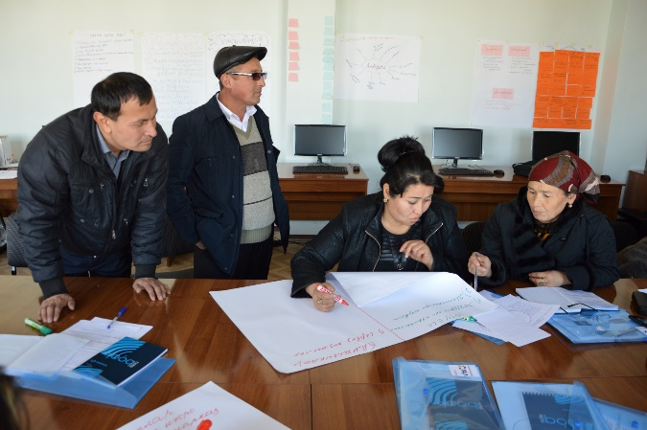
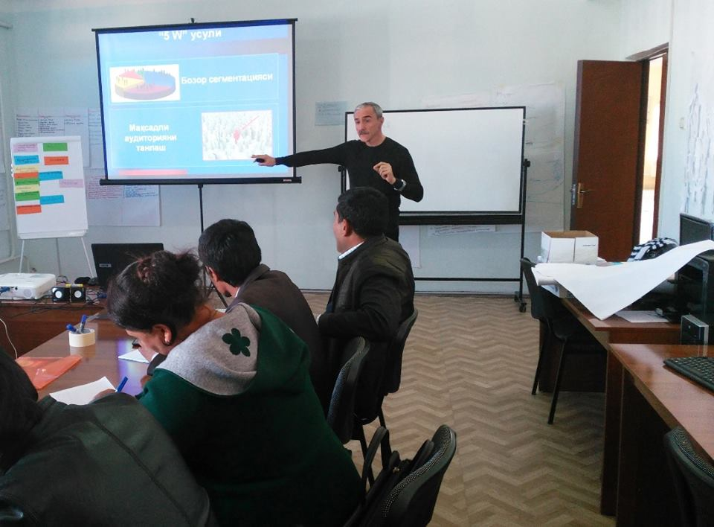 | 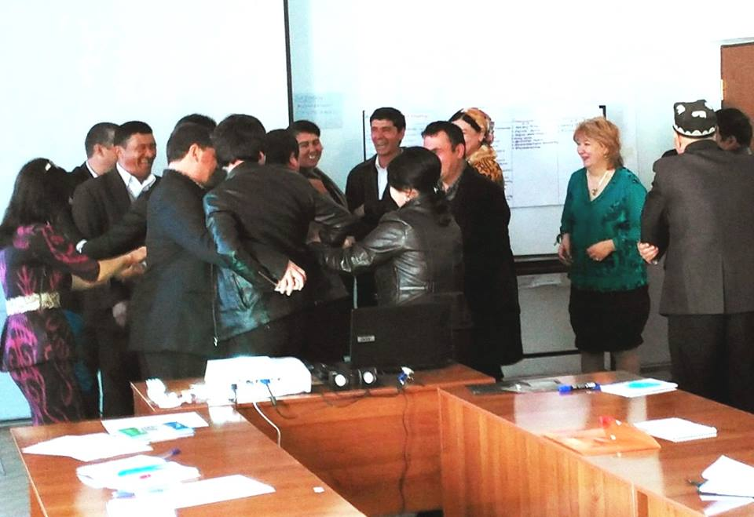

PHOTOS FROM THE PROJECT LIFE:
COURSES FOR POPULATION OF NAMANGAN REGION

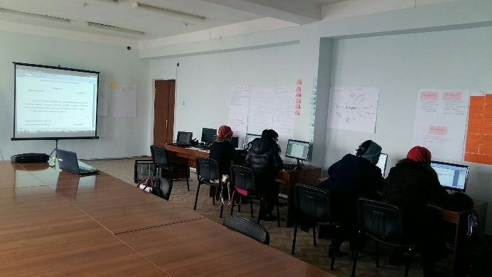 | 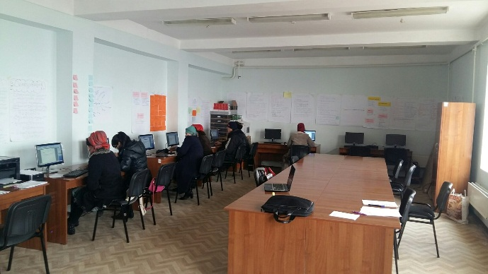
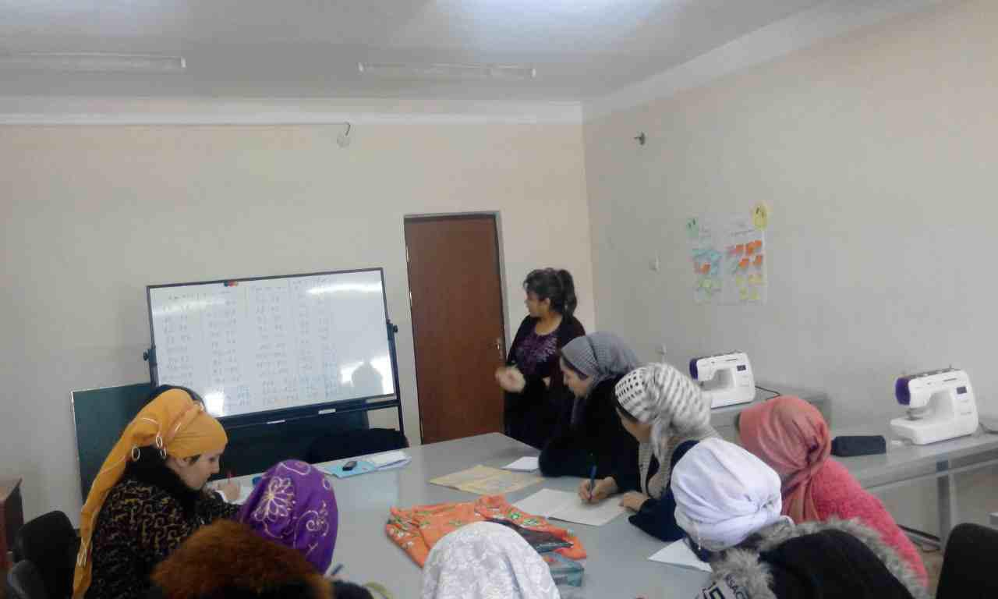 | 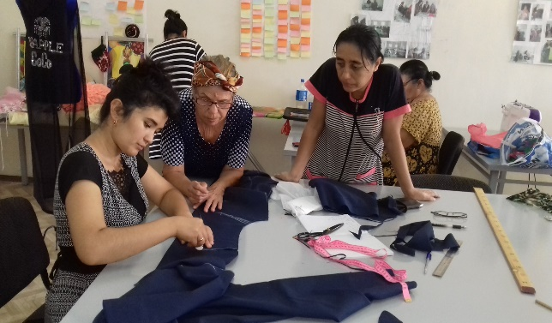
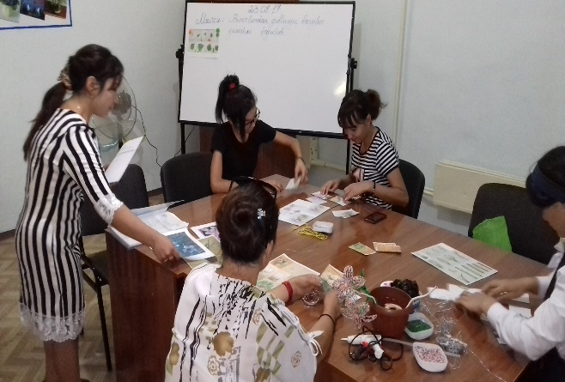 | 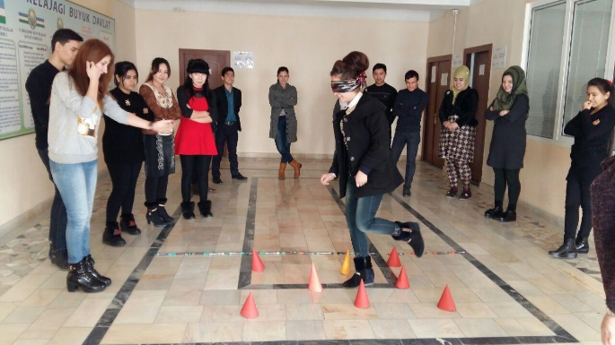

Annex 2

PHOTOS FROM THE PROJECT LIFE:
REPAIR AND EQUIPMENT OF LCLP PREMISES OF KARSHI DISTRICT

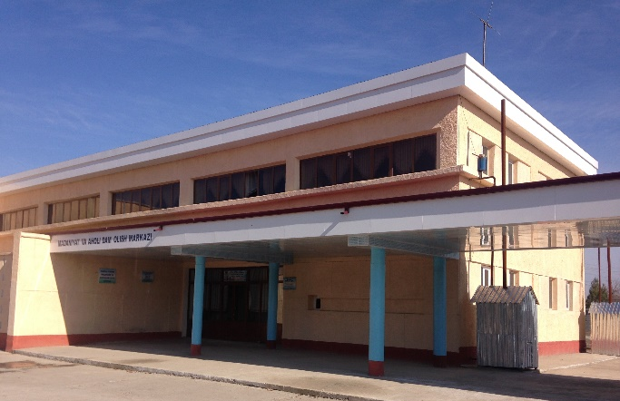 | 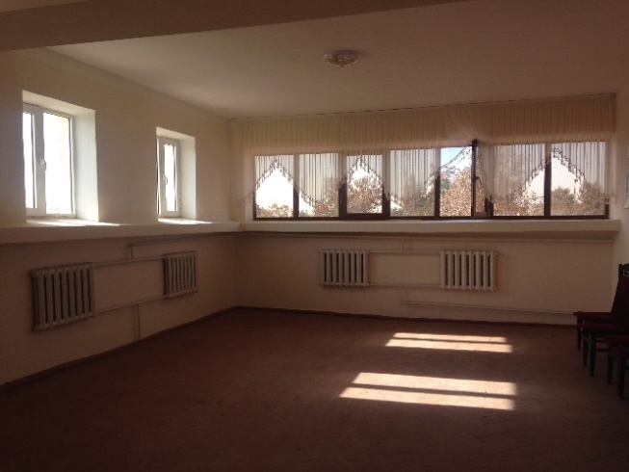
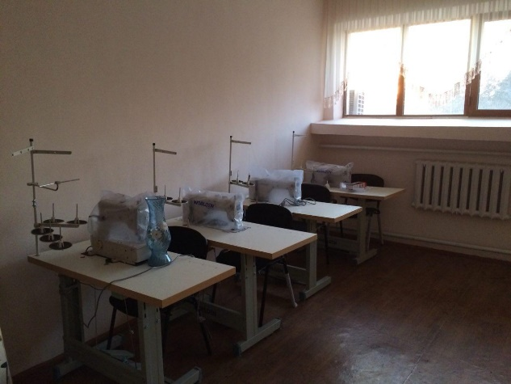 | 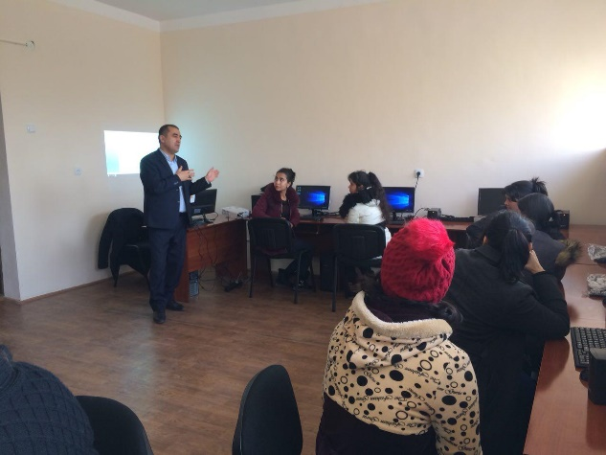
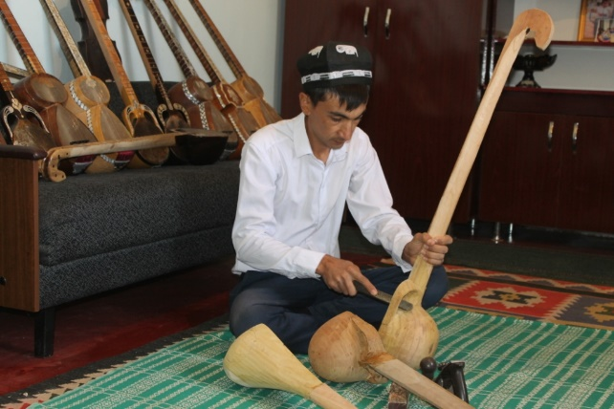 | 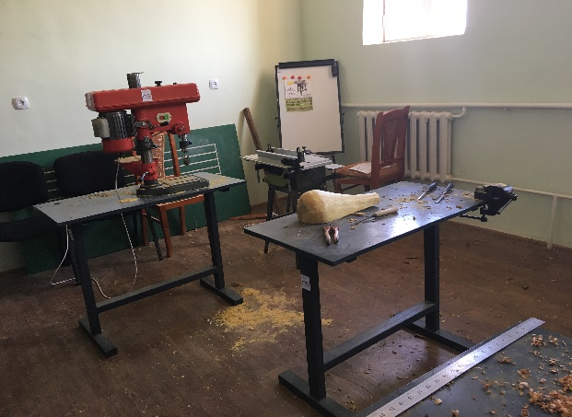

PHOTOS FROM THE PROJECT LIFE:
TRAININGS / SEMINARS FOR EMPLOYEES OF CLCP IN KARSHI DISTRICT

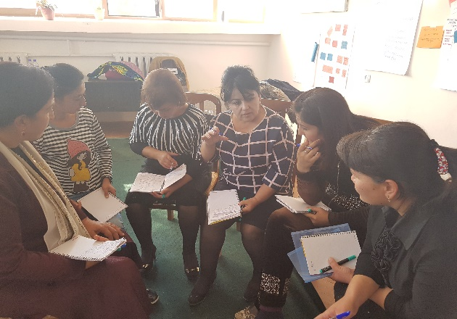 | 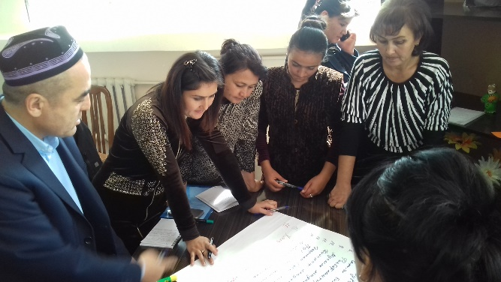
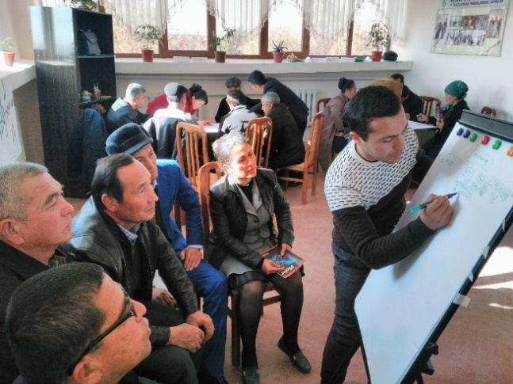 | 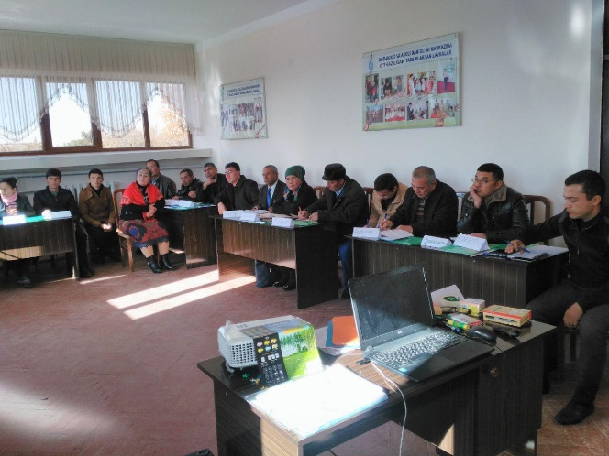
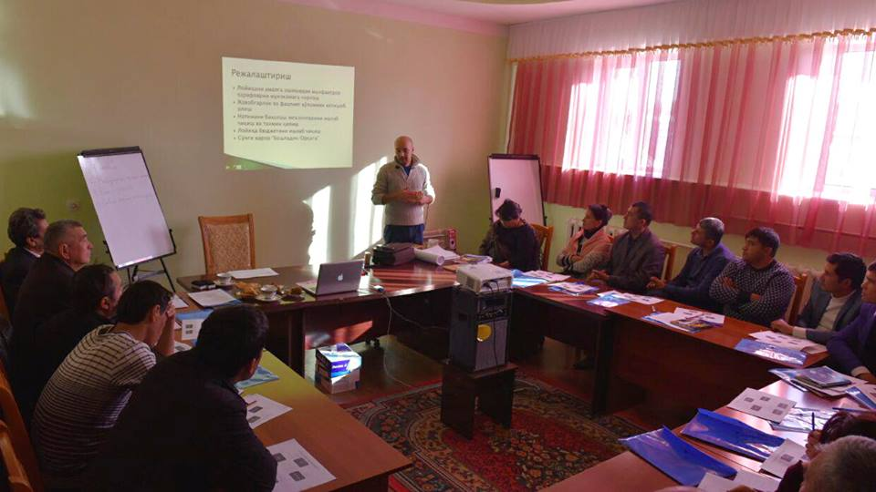 | 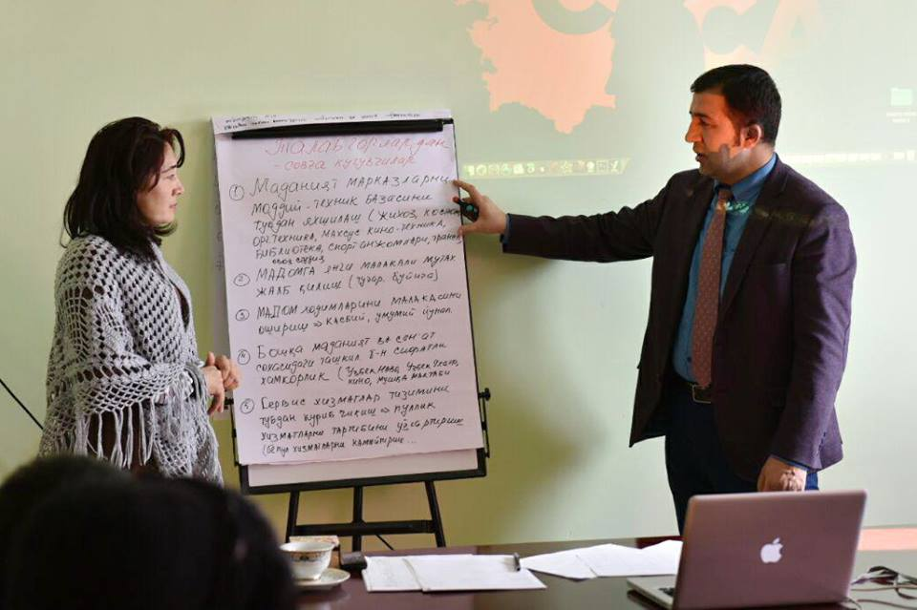

PHOTOS FROM THE PROJECT LIFE:
COURSES / SEMINARS FOR POPULATION OF CLCP IN KARSHI DISTRICT

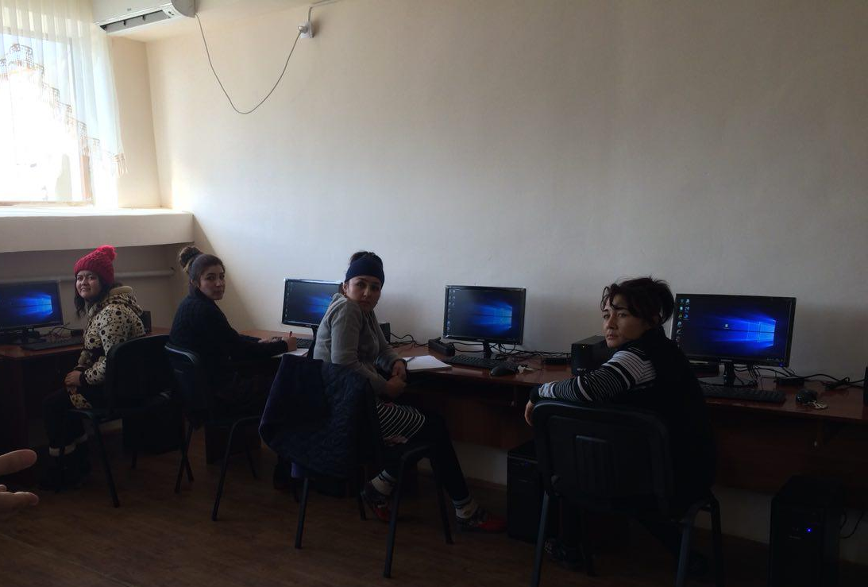 | 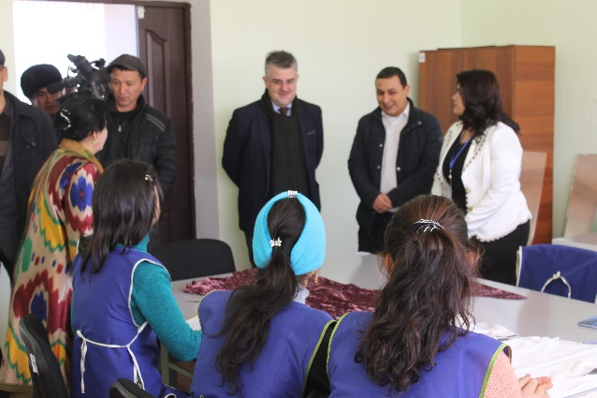
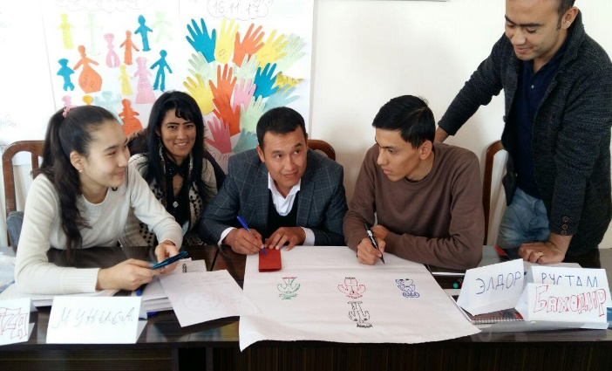 | 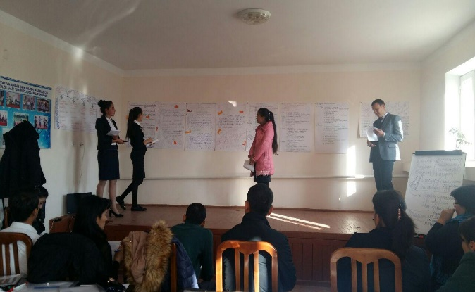
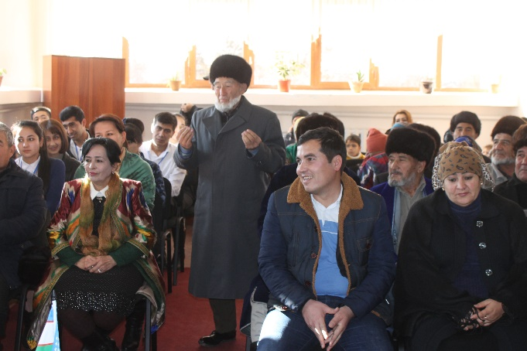 | 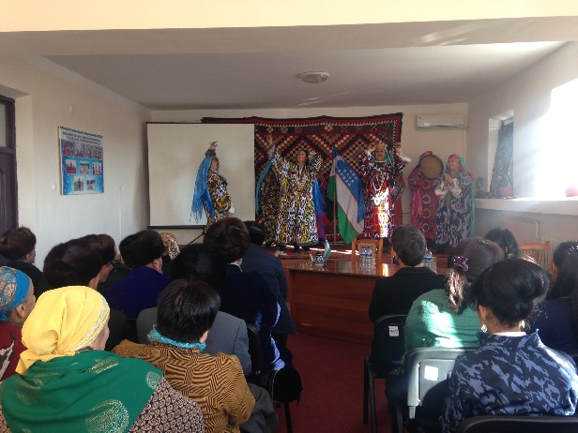

Resolution of the Cabinet of Ministers of the Republic of Uzbekistan No. 178 dated June 25, 2013.
International Program on training specialist for the Adult Education.
http://dsmi.uz/index.php/homepage/28-otdely/101-ob-institute

